# Thamco Store Web App Deployment

The Thamco Store Web application is hosted on Azure, there are two versions of the application a production version and a staging version. By having two different versions it means that changes can be tested and verified on the staging application before being deployed to the production version. This could help minimise downtime of the application as there would be less chance for bugs and errors to affect the production store. It would also be possible to have the staging application connect to a different database than the production one. This would allow thorough testing to be carried out as the production data would not be affected.

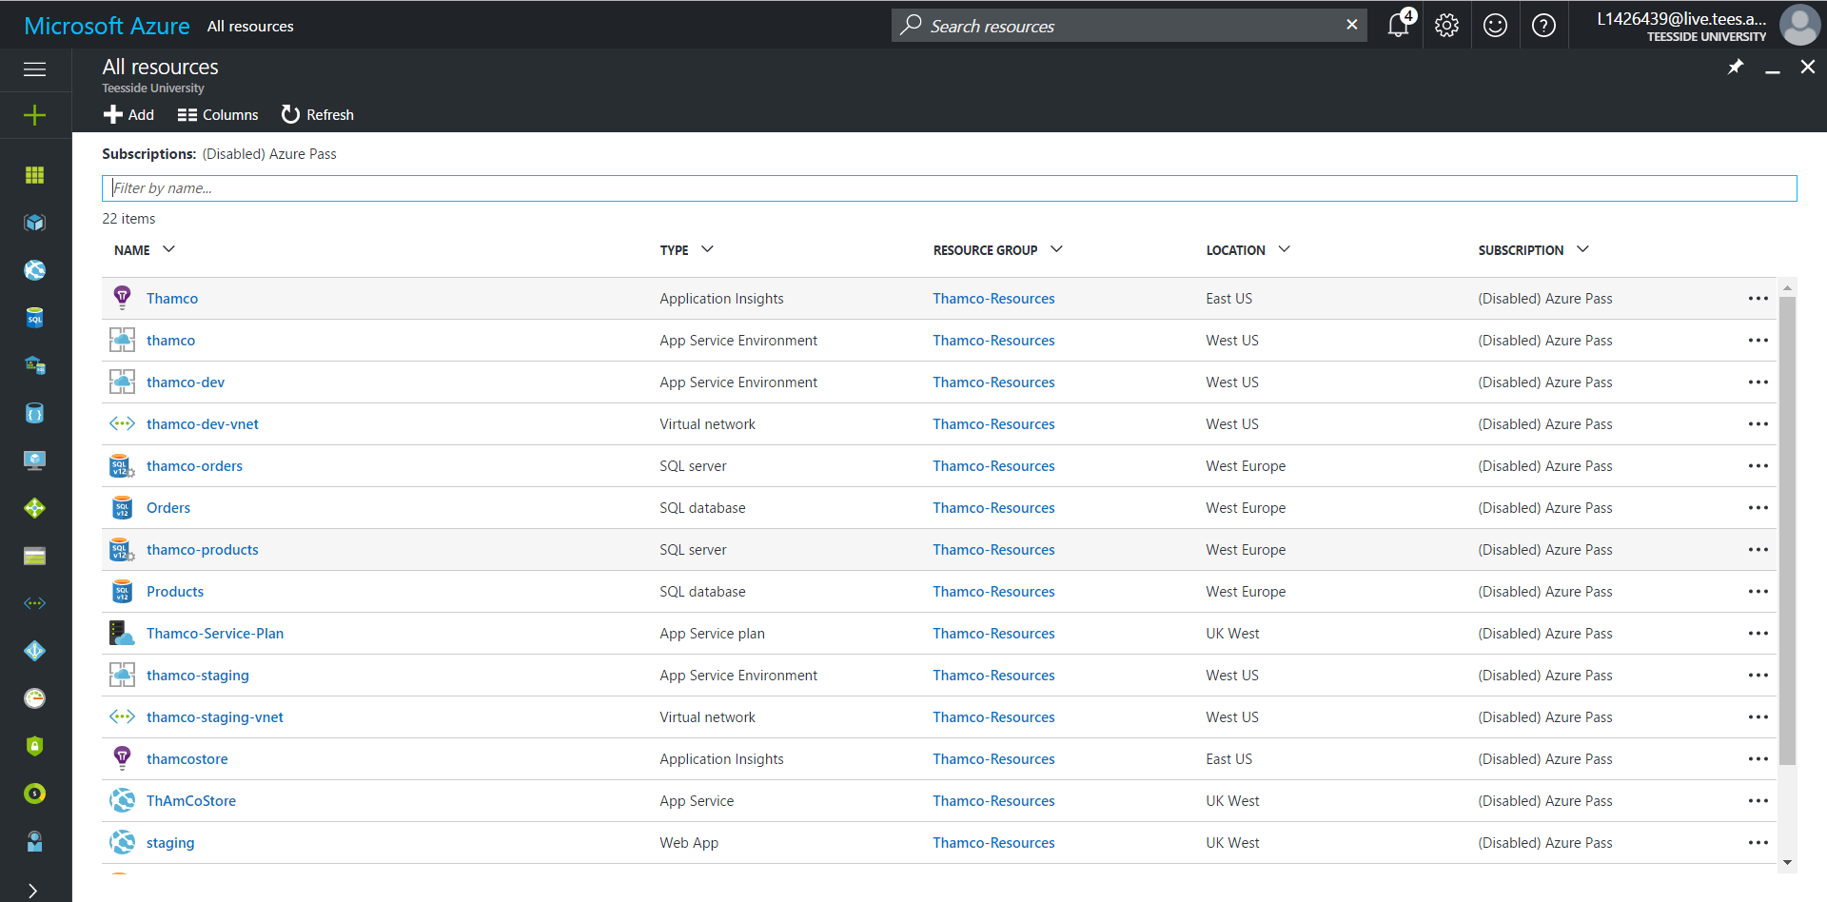

The web application also uses continuous integration for successful deployment to the staging environment. This allows development and local testing to be carried out on the developers machine. Then once it is pushed to the code repository it is built on the server to make sure everything compiles then it is deployed to the staging environment.

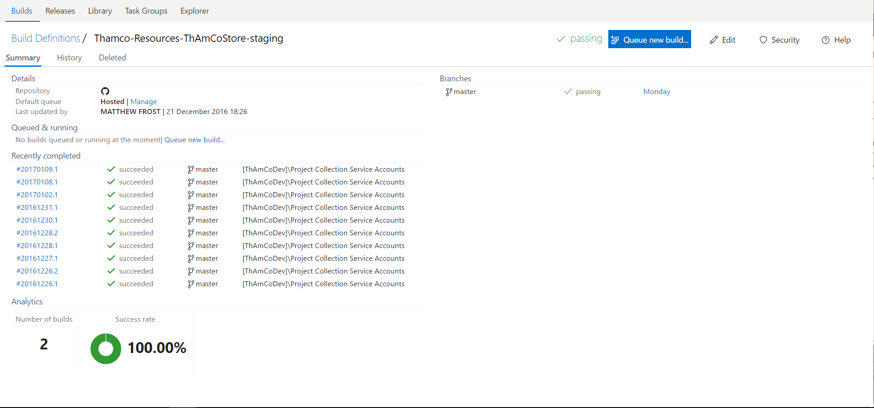

Once the deployment has been successfully built and tested on the staging environment it can be swapped with the version on thr production environment through Azure.

